## Exercise 3.1: Create Recipe: Special Layout for Landscape

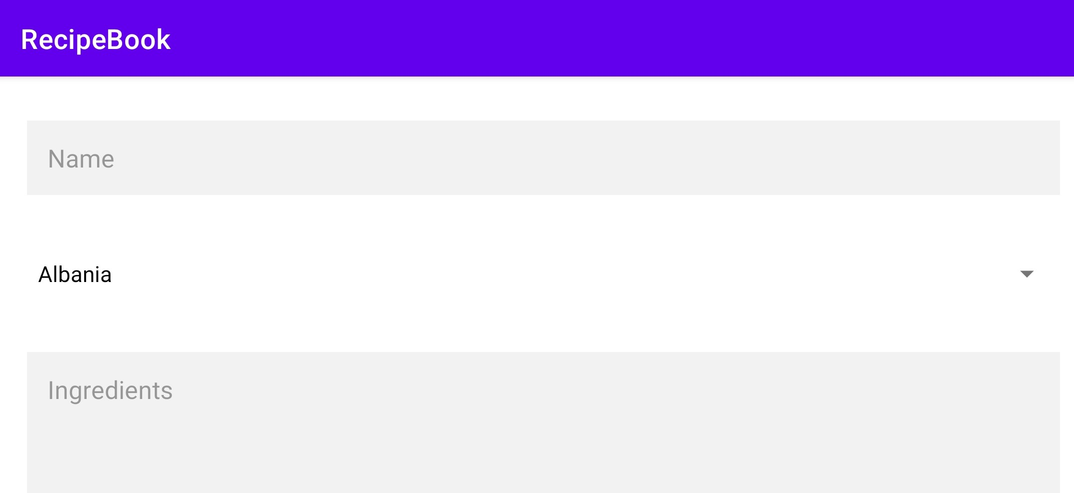

Create a different layout for your create recipe activity that gets shown whenever the device is in landscape mode.

Create a new layout resource, copy your default layout and adapt it such that the UI elements fill the whole screen (see picture above).

Hints:

* You can rotate the virtual device in the emulator using the controls in the bar next to the screen window.

## Exercise 3.2: Your own Launcher Icon for the Recipe Bug

Replace the Android robot with an individual icon for the launcher. You can use an image from the web or the one provided in the materials folder.

## Exercise 3.3: Images for the Recipe List

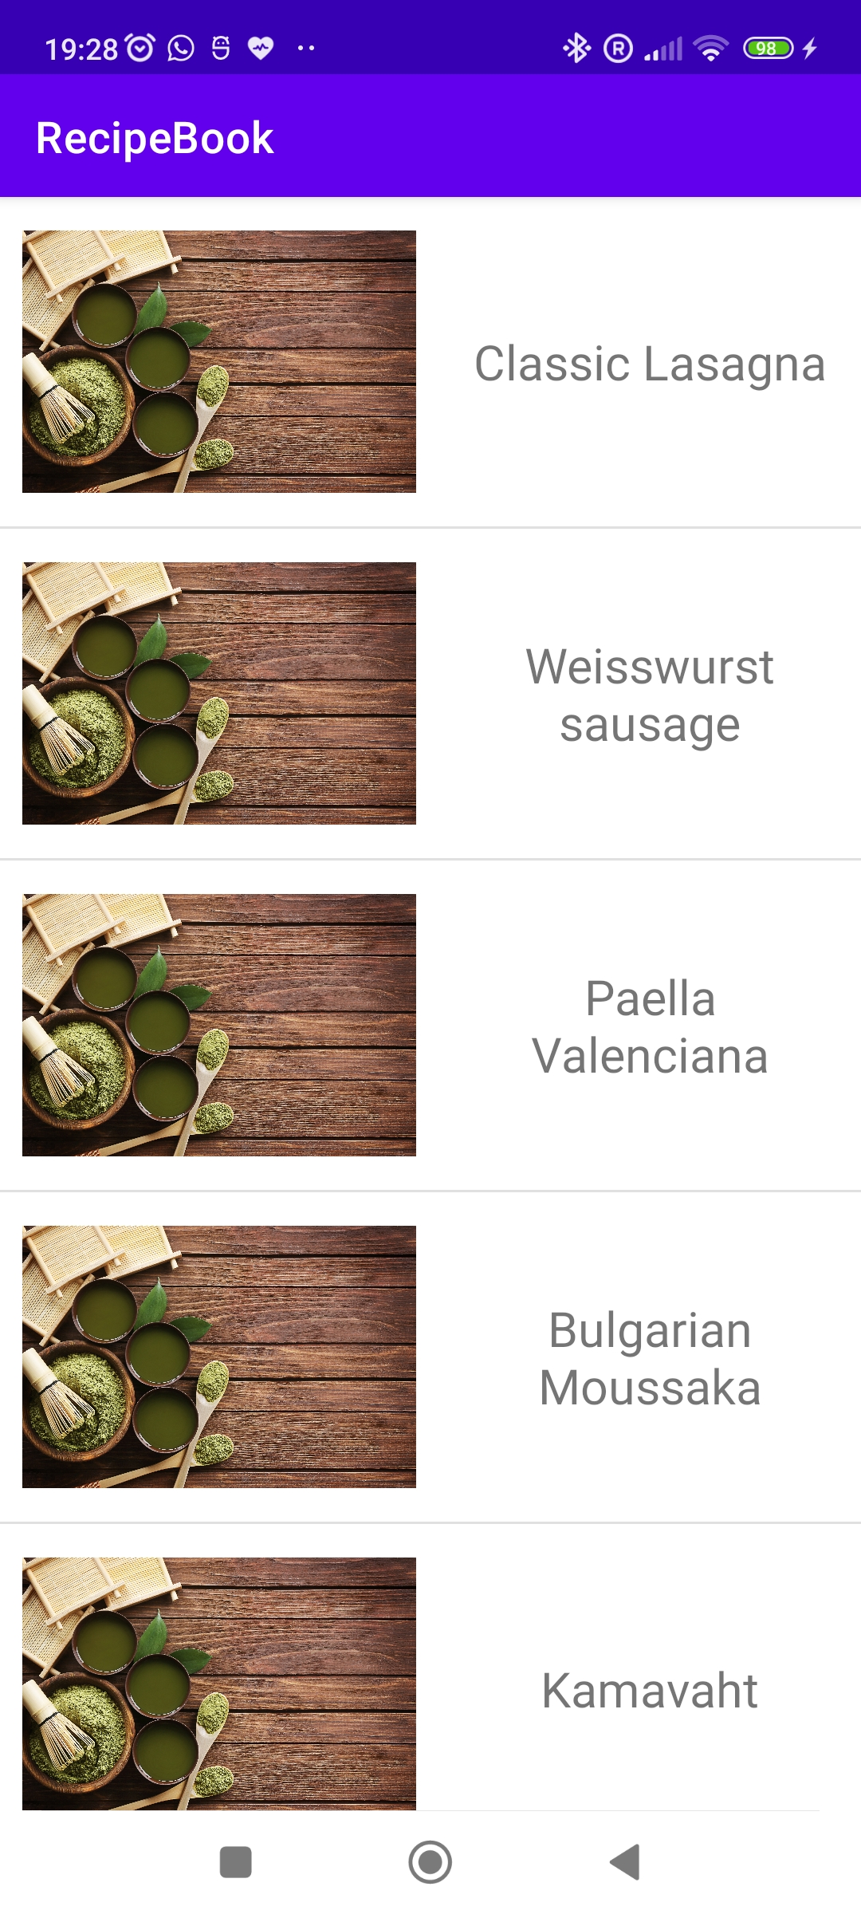

Next, we will beautify the interface of our recipe list with images of the dish. For now, we will use a placeholder image and later replace it with a real picture of each dish (see picture on the right).

Do the following steps:

1. Take the file dish_picture_placeholder.jpg from the materials folder and *Copy&Paste* it to the drawable-folder of your project.
2. Extend the layout for your ListView entries with an ImageView for the picture (width/height 200dp/150dp)
3. Implement a custom RecipeListAdapter that creates View objects that contain image and text (Layout: LinearLayout horizontal).
4. Use RecipeListAdapter instead of ArrayAdapter for the view as well as the ListView from exercise 2.4.

Remarks:

* Possible starting point for your adapter implementation:

public class RecipeListAdapter extends BaseAdapter {

private List<Recipe> data;

public RecipeListAdapter(List<Recipe> data) {

this.data = data;

}

@Override

public int getCount() {

// TODO

}

@Override

public Object getItem(int position) {

// TODO

}

@Override

public long getItemId(int position) {

// TODO

}

@Override

public View getView(int position, View convertView, ViewGroup parent) {

Context context = viewGroup.getContext();

String recipeName = data.get(i).getName();

// TODO: (Create and) Initialize view with text and image

}

}